BLACK JACK TRUST YOUR HEART  - b/w/mottled  - DNA/CEA - normal  - HD-A  - TNS - N/N - normal   | ROY ISDS 266416  Smooth b/w  HD A  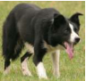 | BOB ISDS 224454  Medium b/w  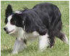
NELL ISDS 244346
Rough b/w/tan
 | ASTRA PEPPER ISDS 278040  Rough b/w/mottled  HD A  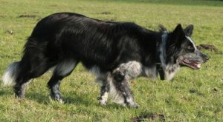 | ASTRA MARS ISDS 248493  Rough blue merle  DNA CEA Normal  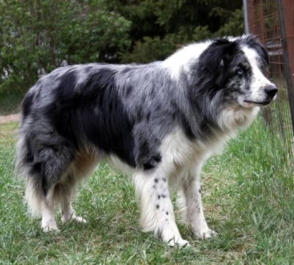
ASTRA PRIDE ISDS255649
Smooth b/w/tan
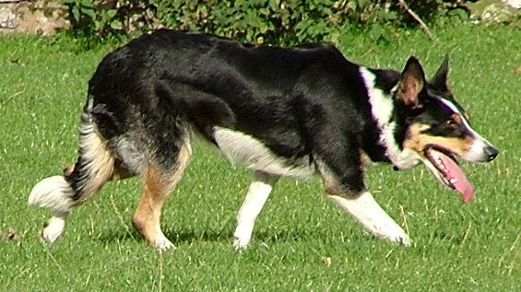

Shadyho tatínek

Shadyho maminka

CORRIE GULDEN LAND  - rough blue merle  - PRA, CEA-neg.  - HD B  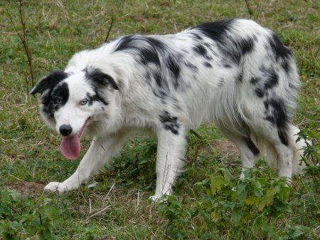 | AKTIV GULDEN LAND  Rough Blue merle/tan  DNA/CEA-normal  PRA-neg  HD A  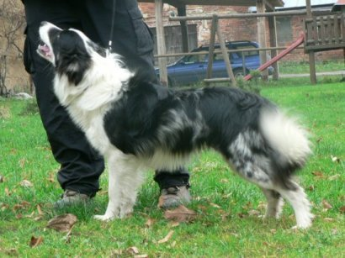 | BOMBER JACK von SUMELOCENNA  Rough Blue merle/tan  HD A,  DNA/CEA-normal  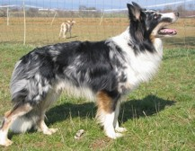
BONIE z NEČTINSKÉHO PODHRADÍ
Rough b/w
DNA/CEA-normal
HD A
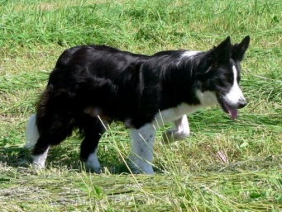
 | JESS MIVEKO  Smooth b/w  PRA, CEA-neg.  HD C  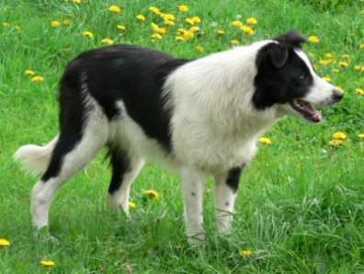 | AXI z OVČÍHO KOPCE  Smooth b/w/tan  HD A, PRA,CEA-neg  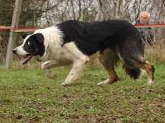

FAIRLEA NAN

ISDS
Smooth b/w
HD A
PRA,CEA-neg

